Program 2: The (Re-) Constructed Image

PAISAJE CON CUERVOS
Jorge Méndez

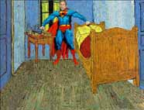

Political ironical criticism of the expansionist ›American‹ culture. Using Van Gogh's room as a scenario of pillage and a remodeling of George Bush, until it (the room) becomes a Pop-Art chamber.
Jorge Eduardo Méndez, *1980 in Bogotá, Colombia, studies Arts at the Universidad Nacional de Colombia since 1998.
// Columbia 2003, 1:35
// Realisation: Jorge Méndez

DRAMATURGISCHE IKONOLOGIE: ROADMOVIE
José Miguel Alves Silva de Andrade Biscaya

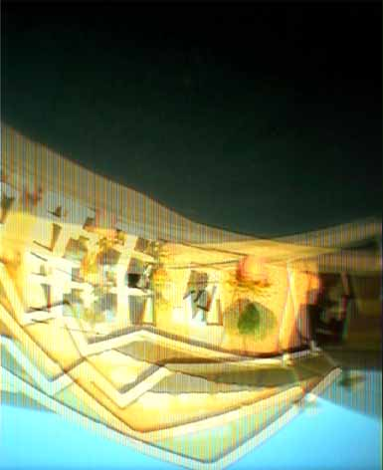

To make a delicious strawberry milkshake you need to carefully mix the ingredients with an electrical blender. The same applies tosoups, sauces and other culinary finesses. With the camera mounted to the front wheel of my car, I was able to mix the main ingredients for a road movie. It is a short journey that doesn't lead anywhere. The whisked images charge the film with a feeling of madness, disaster and, at the same time, this feeling experiences euphoric and hysteric climaxes. In my cinematic conversions of simultaneously extraordinary and trivial things I fall back on a wealth of inspirational sources from our visual culture: from tacky, colourful media images from advertising and soap operas to symbolic representations of sacral icons. The subliminal dramatic aspect is always linked back to the sphere of normality, the unspectacular, the usual. My objective is to simulate situations that pretend to continually change but at the same time celebrate the standstill in a type of endless loop. (José Miguel Biscaya)
José Miguel Alves Silva de Andrade Biscaya, *1973 in Lissabon, Portugal. 1999-2003 AKI, Enschede, NL (academy of fine arts and industrial design). 2003 scholarship ›Transistor Project‹, Schloss Ringenberg, Germany. 2004 Solo-exhibition ›Going Nowhere‹, Schloss Ringenberg, Germany.
// D 2003, 5:30
// Realisation: José Miguel Alves Silva de Andrade Biscaya

BANLIEUE DU VIDE
Thomas Köner

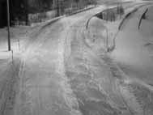

›Banlieue du Vide‹ deals with surveillance and emptiness. During the last winter media artist Thomas Köner collected (via the Internet) about 3000 pictures taken by surveillance cameras. The images he selected show empty roads at night, covered with snow. The soundtrack consists of grey noise and traffic sounds, quoted from memory. The only movement that is visible are the changes of snow covering the roads. ›Banlieue du Vide‹ was awarded the ›Norman prize 2004: Best Film / Video‹ (Filmwinter Stuttgart) and the MuVi-Award at Kurzfilmtage Oberhausen and currently the Golden Nica „Digital Music“ at Ars Electronica, Linz.
Media artist Thomas Köner is working with sound, film and installation since 1990. Presentations a.o.: Louvre Auditorium 1994, Centre Pompidou 1998, Hayward Gallery London 2000, Rotterdam Filmfestival 2001, Walker Art Center Minneapolis 2002, Biennale Filmfestival Venedig 2002. Awards: New Media Prize Montreal 2000. Norman Prize 2004, Filmwinter Stuttgart. His music-CDs are released by Mille Plateaux.
// D 2003, 12:30
// Director: Thomas Köner
// Distribution: LightCone, Paris

MOMENTUM

Martijn Veldhoen

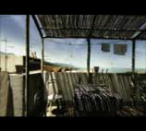

To go is a verb that refers to movement, without being specific about its nature. Walking, driving or floating, for example, are much clearer in this respect; they describe the movement as something that is connected to the body. In ›Momentum‹, as viewer, we go in one slow movement through a sequence of spaces. Through corridors, rooms, doors, over balustrades onto a patio, to the street, and then back inside through an open window. Having acquired the ability to take spatial barriers effortlessly, we seem to be losing our physical form. The disappearance of our body silently echoes in the total absence of people
in the places we pass through. And perhaps also in the voice we hear, the voice that tells us about an undefined loss. (Netherlands Media Art Institute, Vinken & van Kampen)
Martijn Veldhoen, *1962 in Amsterdam. 1979-1984 studied at the Gerrit Rietveld Academie, Amsterdam. Guest lecturer at the Kunstakademie Minerva, Groningen and at the HKA, Arnheim from 1999-2000. ›Momentum‹ was shown as an installation in 2003 at Apeldoorns Museum, Apeldoorn and at the exhibition ›Monitoring‹ in the Kulturbahnhof, Kassel.
// NL 2003, 5:50
// Director: Martijn Veldhoen
// Distribution: Netherlands Media Art Institute – Montevideo, Amsterdam

THE LIGHT
Brian Doyle

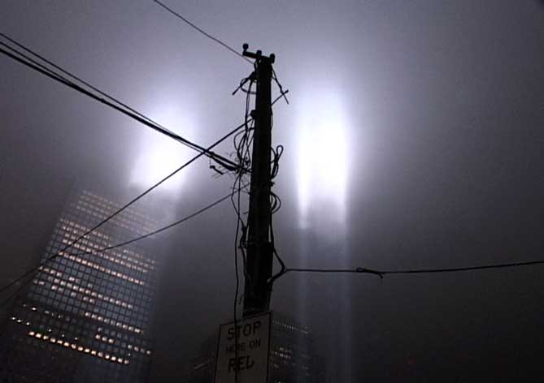

›The Light‹ reveals a world that cannot see its way. The invisible populace of this world, present only through the objects of their creation, attempts to illuminate paths through the unknown. Their ultimate fate and quiet fear - everlasting darkness - must be kept at bay, and so unfolds a parade of growing and ever more complex illuminations. Building gradually from one lone street lamp to the brightest light ever made, ›The Light‹ culminates as a metropolis' beacon, reaches skyward and the elements bear down through its beams. Ultimately, the attempt to pierce the night, to know the unknown, ends in somber quiet. Light becomes a metaphor for human struggle, through technology and determination, to see through the darkness.
Revealing subtleties found within the collision of cultural and natural phenomena, Brian Doyle's work
questions the notion of common experience. The videos, installations, and photos that emerge are semi-fictionalised documentaries. Doyle's award-winning videos have been shown on television, at film festivals, and in galleries around the world. He graduated with a BFA from Florida State University and an MFA from the School of the Art Institute of Chicago's Sculpture Department. He lives and works in Brooklyn, NY.
// USA 2003, 10:18
// Director: Brian Doyle
// Distribution: Netherlands Media Art Institute – Montevideo, Amsterdam

PLANCK'S CONSTANT PLANCKIN VAKIO
Pekka Sassi

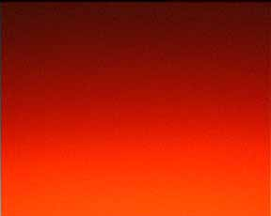

A study on light that cannot be seen. A video camera shoots the monitor that shows the image from the camera in real time. The aperture is adjusted until the light reaches a point where it seems to be present as a being. The moving image, the light, materialises through the blinking, and produces creatures.
»My works are usually installations where moving image with its tradition is strongly present. I'm interested in making films by not using a camera or even a projection. Lately I've been studying cubism in narration and representation. In my tape works I deal with the question of the viewer's place between the sound and image.« (Pekka Sassi)
Pekka Sassi, *1969. Lives and works in Helsinki, Finland. Works consist of installations, sound, short films and music.

// FIN 2003, 3:55
// Realisation: Pekka Sassi
// Distribution: AV-ARKKI, Helsinki

UTRECHTER HÜTTE
Franz Höfner

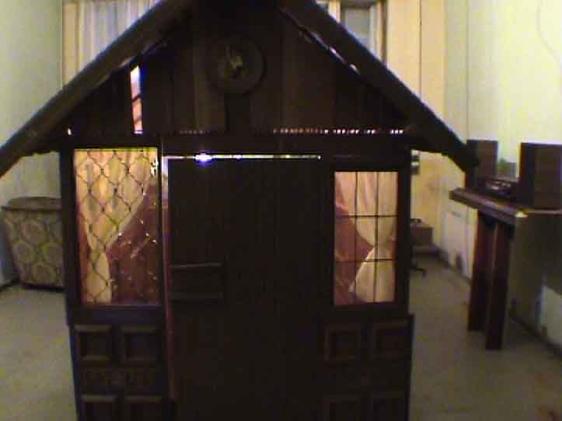

This video displays the mutation of a wall unit called ›Utrecht‹ to a real hut, the ›Utrechter Hütte‹, on the ground plan of a living room. This unique diversity of a wall unit combines contemporary functionality with traditional charm. It only needs little place and therefore gives additional storing space to your living room. Consequently, even the smallest apartment can become a big house!
Franz Höfner, *1970 in Starnberg, Germany, lives in Berlin. 1993-1994 Film- and TV Sciences, Bochum. 1994-2000 Fine Arts at Bauhaus-University, Weimar. 1998 Erasmus exchange, Politecnica Valencia, Facultad Bellas Artes, Spain. 2000 Master of Fine Arts. 2003 RADAR grant in cooperation with ›La Biennale di Venezia 2003.
// D 2002, 2:35
// Director and Performer: Franz Höfner

