Program 1: Stories Behind the Screen

NUMMER TWEE JUST BECAUSE I'M STANDING HERE DOESN'T MEAN I WANT TO Guido van der Werve
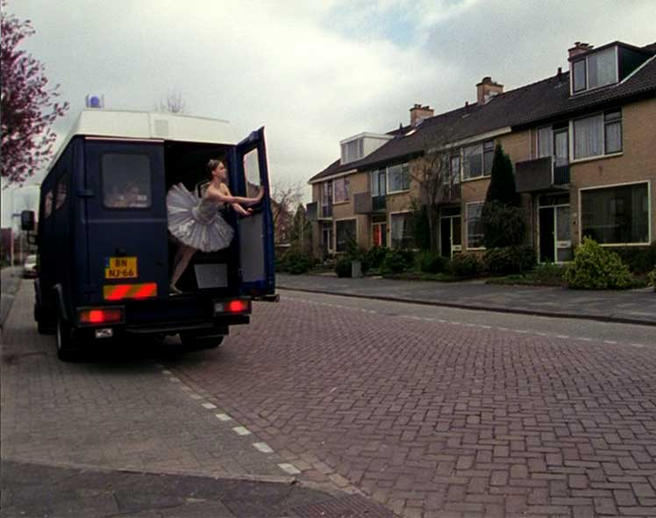

In my works I always look for elements that are metaphors for the state of mind I'm in at that particular time and place. These elements express in a direct and non-rational way my feelings, but I don't expect or want the audience to guess what my motives are for picking these elements. I prefer to put them in an open context. Usually I transfer these elements to performances. The ideas for the elements of ›Nummer twee‹ came from Russia. I studied Russian for two years and during this period I was on an exchange at the St. Petersburg State University. I lived there for two months at the campus. This campus was located next to an 18-lane highway. Almost every week I witnessed a car accident. In the evenings I went to the theatre most of the time. With my student card I could get tickets for almost nothing. Also the text at the beginning of the film is from my diary at that time. (Guido van der Werve)

Guido van der Werve, *1977 in Papendrecht. 2001-2003 U.V.A. Russian Language, Culture and Literature. 2002 State University St. Petersburg (Russian Language). 1998-2003 graduated from Gerrit Rietveld Academy. 2003 Guest teacher at the Rietveld Academy, Department VAV. 2004 Guest teacher in the Iceland Academy of the Arts. Solo Exhibition ›I don't want to get involved in this‹, ›Pand Paulus‹, Schiedam. René Coelho Award from MonteVideo for ›Nummer Twee‹ and the second prize media award Friesland.

// NL 2003, 3:08
// Realisation: Guido van der Werve
// Performer: Guido van der Werve, Magnus Logi Kristensson, Wil Trumpie, Margie Oosten, Marloes Meents, Celine Kraal, Rachel Meibergen, Zunaira Choudry
// Choreograph: Elisabeth Lambeck

OF CAMERA Steven Eastwood

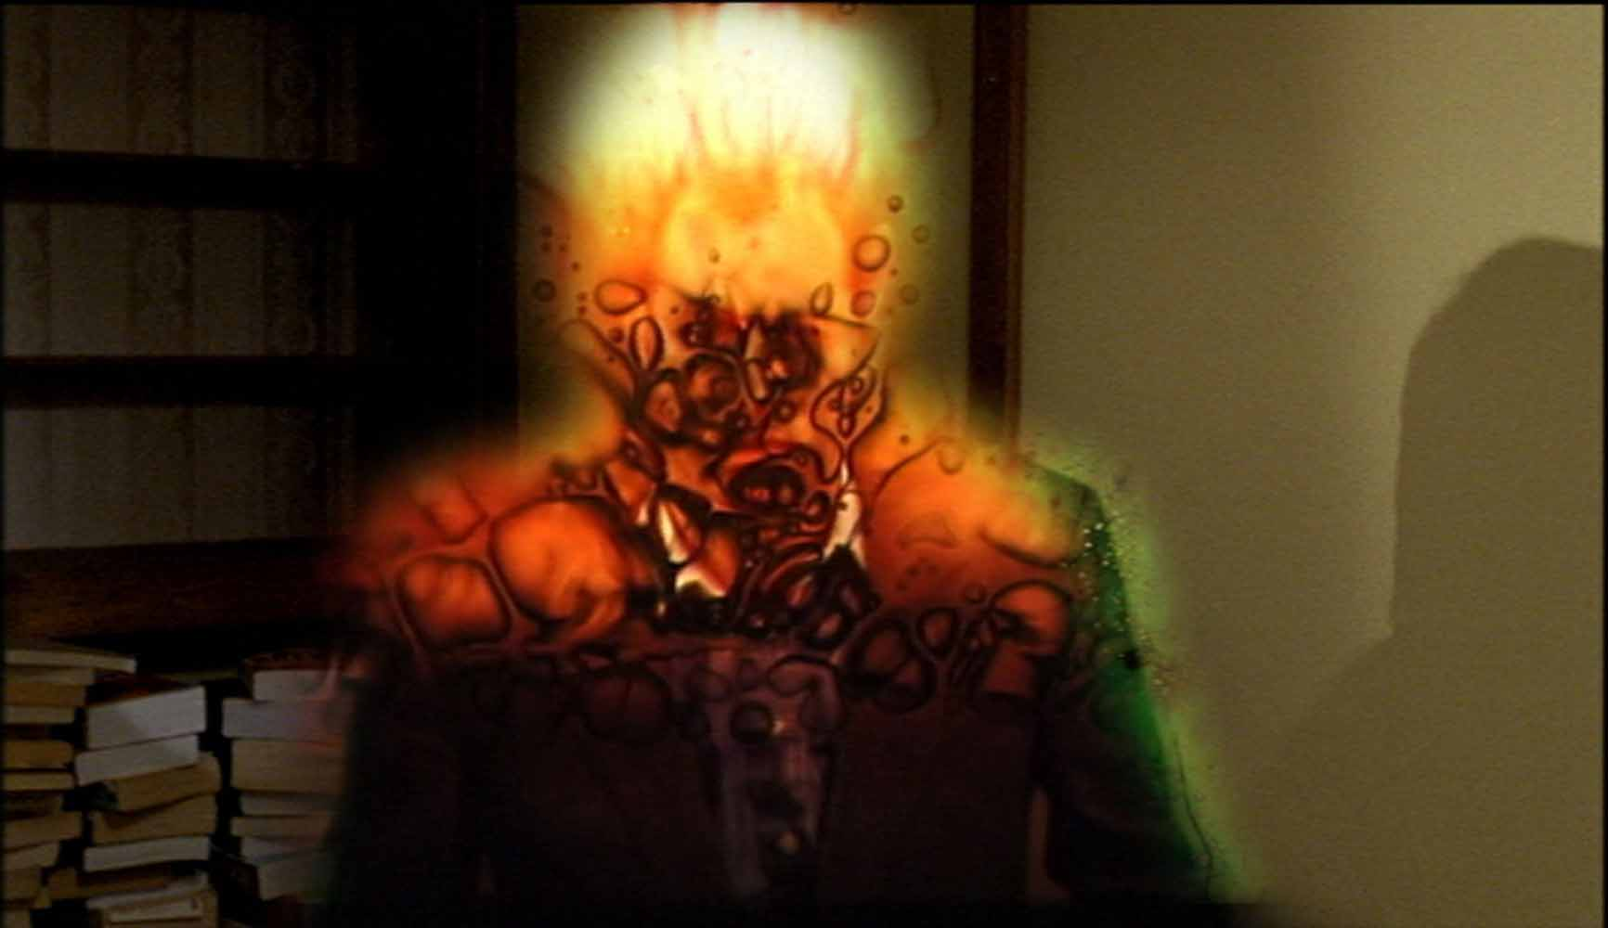

›Of Camera‹ explores the abortive attempts of two people to be together in the same space. Their dis-agreement is fuelled by technical difference: the woman exists on videotape and the man on celluloid. The story corrupts as the two realise they are incompatible and that they are being filmed and watched. The film describes a dread, a noir(ish) situation - that of becoming aware that one is in a frame, is cast inside a narrative which is in the control of others. The differing textures and attributes of video and film become a metaphor for differing traits in people. This is an examination of dissimilarity and the nature of a moving image.

Steven Eastwood is a filmmaker whose practice spans artists film/video, fiction and documentary. His film works have been screened nationally and internationally at arts cinemas, galleries and festivals including the ICA, BAFTA (The Grierson Awards), The Edinburgh Film Festival, UPLINK Arts factory Tokyo, Catalyst Arts in Belfast, the Lux Centre and Lux Open, Anthology Film Archives NYC. Steven is currently undertaking an Mphil/PhD practice-based research project through the Surrey Institute, titled ›Cinema into the Real‹. He has lectured extensively in fine art moving image, documentary/fiction production and in film theory.

// GB 2003, 14:40
// Director: Steven Eastwood
// Distribution: Paradogs, London

WE HAVE DECIDED NOT TO DIE Daniel Askill

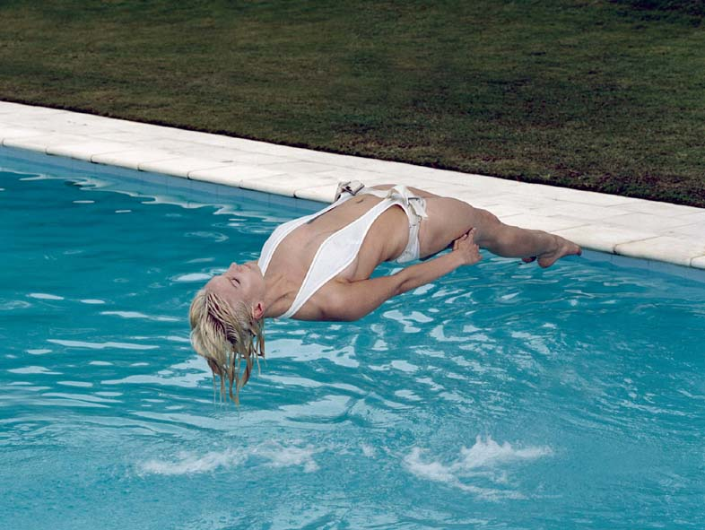

THREE RITUALS. THREE FIGURES. THREE MODERN DAY JOURNEYS OF TRANSCENDENCE.
›We Have Decided Not To Die‹ is about a mental state where logic drops away and anything is possible. It is an audio visual narrative that uses sound, stunts and visual effects to create a world where characters float in space and time. The story tells of three characters' modern day journeys of transcendence; journeys into a place where death is no longer inevitable. »The short film ›We Have Decided Not To Die‹ is unusual. A modern day allegorical triptych, three figures undergo transformation through three rituals. Though not a story in any conventional sense, ›We Have Decided Not To Die‹ succeeds in taking the audience on an emotional journey. Aurally intriguing, often stunning and always beautiful, the film has been winning fans from around the festival circuit. « (Sarah Runcie, AFC)

Daniel Askill, *1977 in Sydney, Daniel has worked internationally as a director of commercials, short films and music videos. In addition to this his background in music led him to release his first album as composer/producer at 19, while also designing record sleeves and multi media projects. Initially studying design in Sydney and later at Central Saint Martins in London, Daniel was picked up as creative director of London agency Williams before completing his studies. During his time there he helmed a wide variety of projects from web design for infamous fashion star Alexander McQueen to directing his first commercial for the desire fragrance by Alfred Dunhill. In 2001 Daniel returned to Sydney to co-found film & design collective COLLIDER.

// AUS 2003, 11:00
// Director, Scipt, Editing: Daniel Askill
// Producer: Christopher Seeto, Daniel Askill
// Design: Andrew van der Westhuyzen
// Music: Michael Askill
// Performer: Ritual 1 Kasia Werstak, Ritual 2 Daniel Askill, Ritual 3 Jordan Askill

LIVING A BEAUTIFUL LIFE Corinna Schnitt
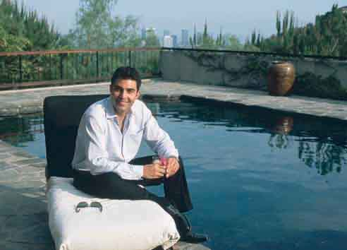

»Imagine a life you dreamt of as a child, i.e. a perfect life.
Seemingly completely naively, Corinna Schnitt takes general wishing and the usual ideas of happiness in life by its word - and mercilessly feeds our eyes and ears on this quasi-documentary production. She shows us a man and a woman, both good-looking, who reside in a stylish villa high above Los Angeles, and who alternately report into the camera that they have got everything and are everything that others can only wish for. Like ›Blade Runner‹ replicas, they list all of the components of an amazingly nice life, just as people, at least in the West, imagine it should be. It is very difficult for the viewer to cope with this exhausting litany of total happiness - and he feels even more provoked by the contemplative mood of the well-composed scenes. And those who assume in between that it will all explode at the end, as in Antonioni's ›Zabriskie Point‹, is mistaken « (Kay von Keitz)

Corinna Schnitt, * in Duisburg. Studied Art and Film at the Hochschule für Gestaltung, Offenbach and at the Kunstakademie Düsseldorf from 1989-96.

// D 2003, 13:00
// Director: Corinna Schnitt
// Performer: Diana Imber, Michael Gianelli
// Found Footage: ›Der Katzenprinz‹, Defa-Film, 1970

'AXE DU MAL AXIS OF EVIL Pascal Lièvre
'AXE DU MAL AXIS OF EVIL Pascal Lièvre

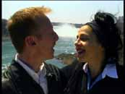

Citing an article on George W. Bush ›Armé pour menacer la paix du monde‹ (Armed to Threaten
World Peace) from the January 31, 2002 issue of Le Monde, the lyrics of ›Un axe du mal‹ are sung to the melody of the original Jermaine Jackson/Pia Zadora song ›And When the Rain Begins to Fall‹.

Pascal Lièvre works and lives in Paris. Considered as a multidisciplinary artist, he is known for his paintings and his videos. His single-channel work has been shown at national and international festivals. For ten years, his paintings have been exhibited in personal and collective exhibitions. In 2003, his video installation ›22 portraits d'inconnus‹ was shown at the Musée Antoine Lécuyer St Quentin at the Le musée revisité event.

// CDN/F 2003, 5:45
// Realisation: Pascal Lièvre
// Distribution: Vidéographe, Canada

